

Cognizance 2022

Task-5



June 24, 2022

Sayan Banerjee

CH.EN.U4CSE20064

# OverTheWire Game

**Connection to SSH**

ssh [-p port] [user@]server [command]

Example: ssh -p 2220 [bandit0@bandit.labs.overthewire.org](mailto:bandit0@bandit.labs.overthewire.org)

**Passwords for each level**

1. boJ9jbbUNNfktd78OOpsqOltutMc3MY1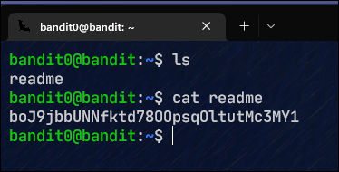
2. CV1DtqXWVFXTvM2F0k09SHz0YwRINYA9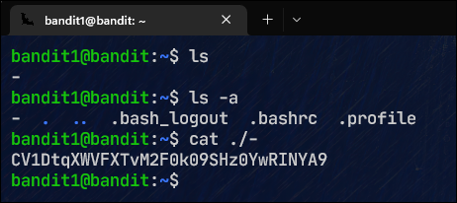
3. UmHadQclWmgdLOKQ3YNgjWxGoRMb5luK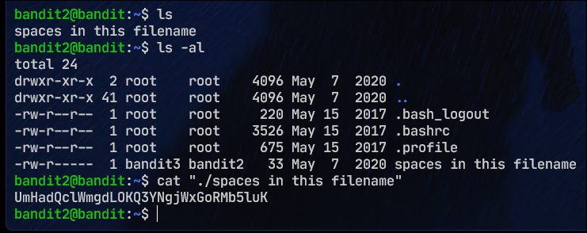
4. pIwrPrtPN36QITSp3EQaw936yaFoFgAB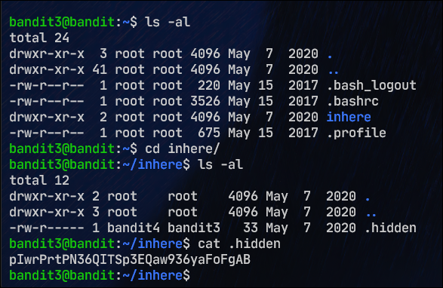
5. koReBOKuIDDepwhWk7jZC0RTdopnAYKh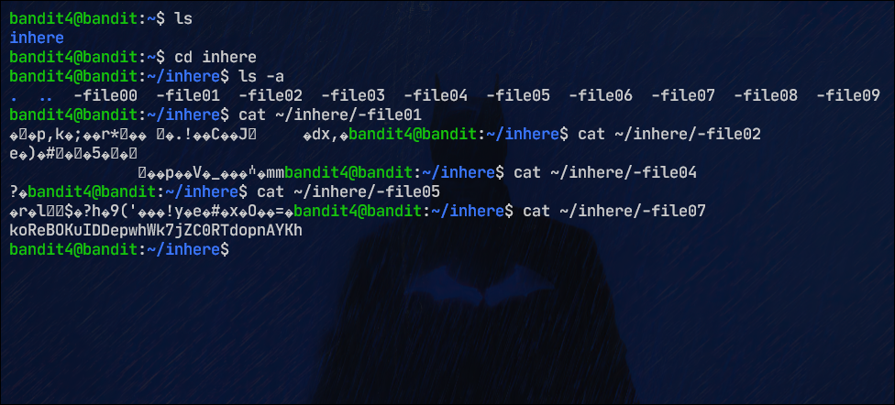
6. DXjZPULLxYr17uwoI01bNLQbtFemEgo7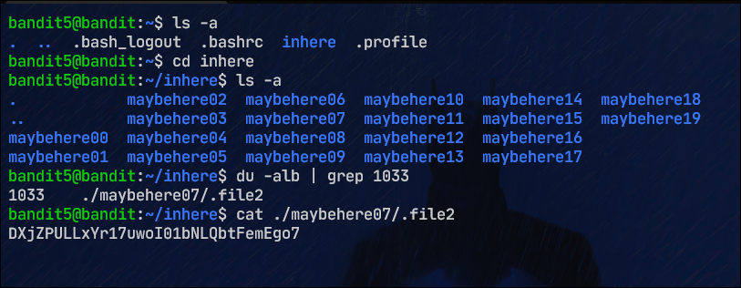
7. HKBPTKQnIay4Fw76bEy8PVxKEDQRKTzs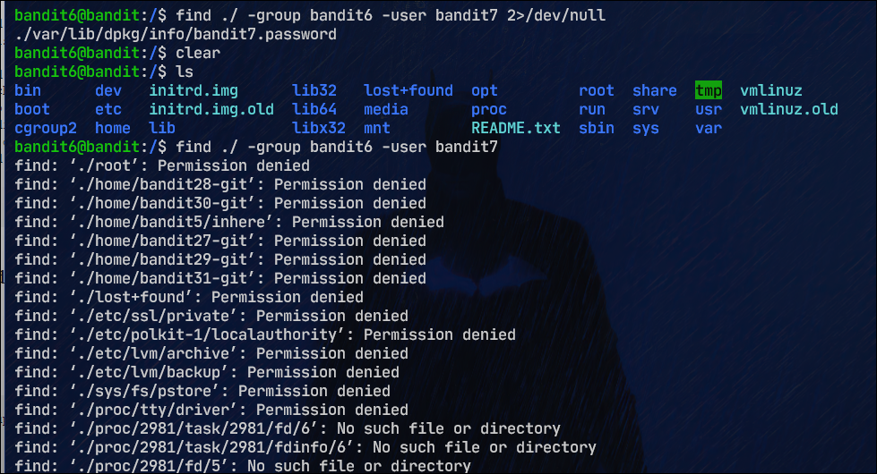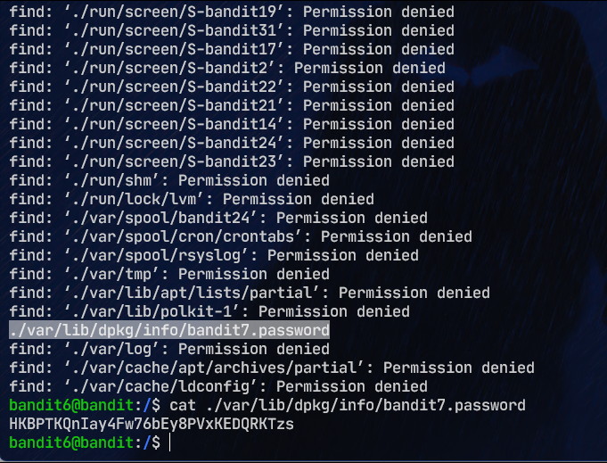
8. cvX2JJa4CFALtqS87jk27qwqGhBM9plV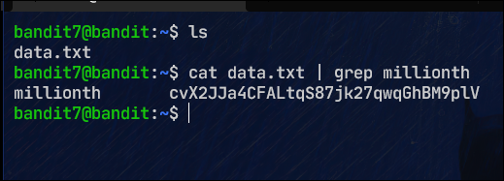
9. UsvVyFSfZZWbi6wgC7dAFyFuR6jQQUhR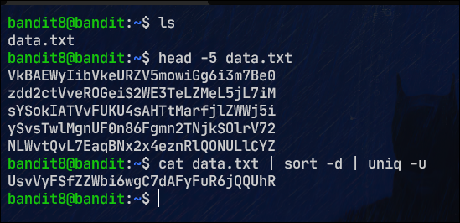
10. truKLdjsbJ5g7yyJ2X2R0o3a5HQJFuLk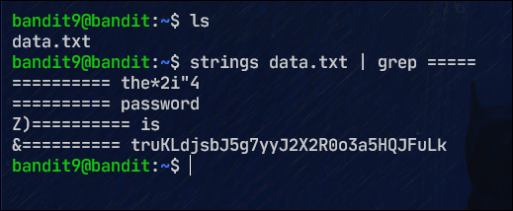
11. IFukwKGsFW8MOq3IRFqrxE1hxTNEbUPR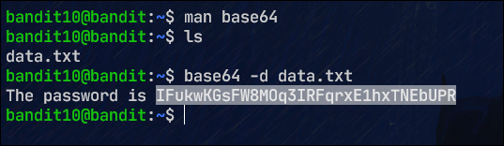
12. 5Te8Y4drgCRfCx8ugdwuEX8KFC6k2EUu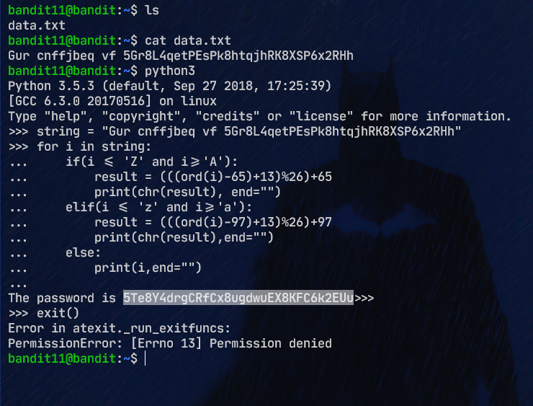
13. 8ZjyCRiBWFYkneahHwxCv3wb2a1ORpYL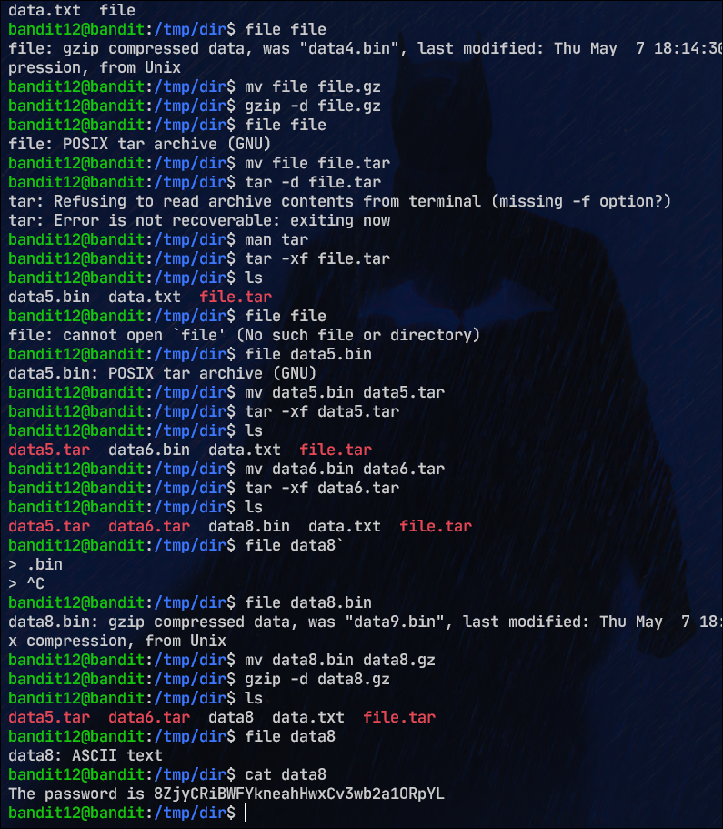
14. 4wcYUJFw0k0XLShlDzztnTBHiqxU3b3e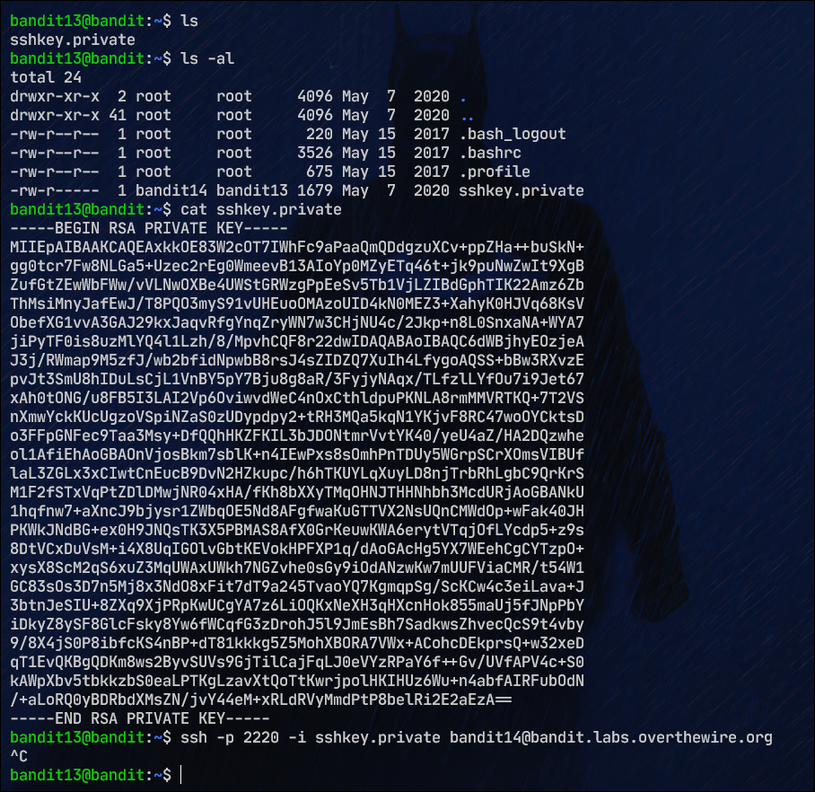
15. BfMYroe26WYalil77FoDi9qh59eK5xNr